Retreats

- Can the title just be Retreats
- Change paragraph under ‘retreats’ title to Whether you’re looking for rest and rejuvenation, fun and luxury, or the confidence to host your own, there’s something here for you. Mind Fit Retreats are for connection, joy and depth, while the F.I.T Trip blends energising classes with five-star spa indulgence. And with years of presenting at and hosting retreats, Faye helps others plan and launch their own as The Retreat Planner.

- Mind Retreats- Mind Fit Retreats: Zanzibar at Zan Boutique Resort
1st-10th February 2027
More than a retreat, it’s a celebration of life. A week at Zen Boutique Resort on Zanzibar’s south-east coast, with mindset workshops, sunrise beach sessions, F.I.T Jam and Combat classes, island boat trips and cultural adventures. Every retreat has its own theme, inviting guests to let go of what holds them back and take up space, surrounded by good people and good energy.
Add a tab – More Info Here
- The F.I.T Trip Spa Break Bulgaria
22nd-26th April 2027
The long weekend of luxury. Three nights at the five-star Grand Therme Hotel in Banya, all-inclusive, with unlimited thermal spa access, heated outdoor pools, salt rooms and saunas and an in spa cinema and outdoor theme park. Enjoy a jam packed timetable of classes or simply relax. Including a party night, entertainment and fun activities like quad biking and horse riding.
Add a tab – More Info Here
- The Retreat Planner
Dreaming of hosting your own?
Faye has presented at retreats worldwide and filled her own, so she knows every detail it takes, from venue and pricing to itinerary, compliance and sold-out bookings. Through The Retreat Planner, she guides fitness professionals from first idea to launch, with options from a masterclass to full-service support on location.
Add tab: More Info Here (will attach in email)

PICTURE FOR F.I.T TRIP BULGARIA
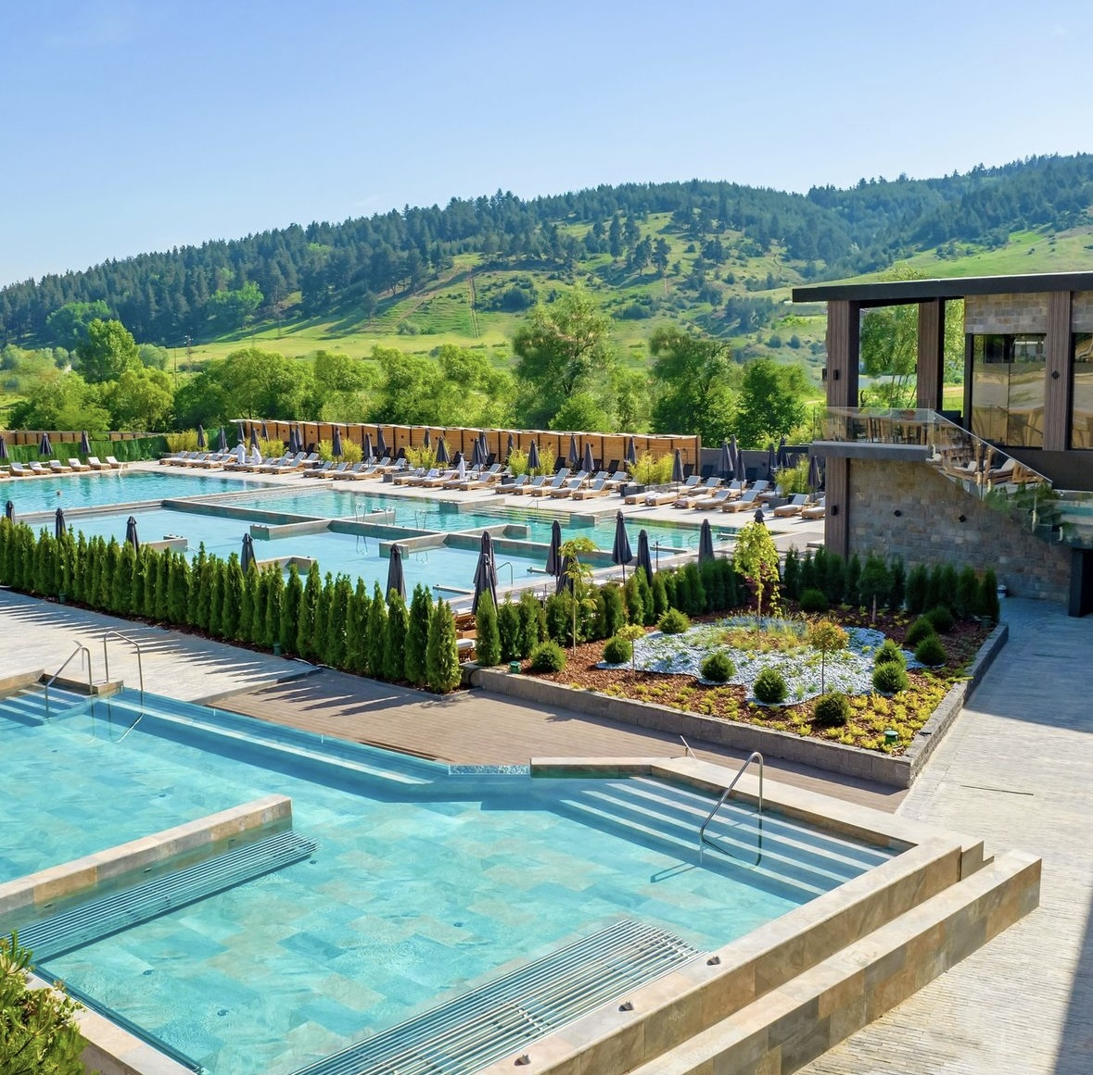

RETREAT PLANNER


